# Vickers Hardness test

# OBJECTIVE: To determine the indentation hardness of mild steel, brass, aluminium etc. using Vickers hardness testing machine.

**Apparatus used:** Vickers hardness testing machine

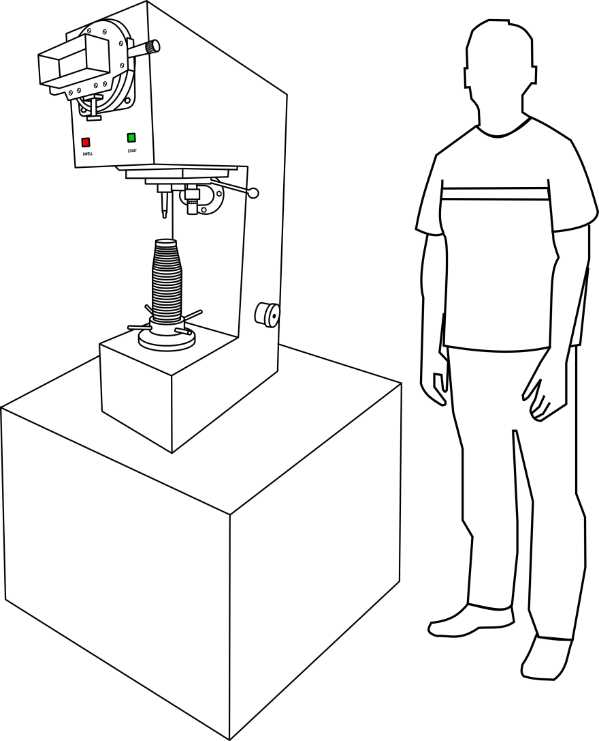

**STEP** ❶: Type of indenter used is diamond cone indenter with square based pyramid shape. Select the type of material. (Simulation: Should be possible to select the specimen by clicking on specimen image)

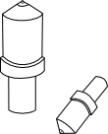

  

STEP ❷: The selected specimen is placed on a supporting table and the height is adjusted by rotating hand wheel. (Rotating of hand wheel same as brinell test)

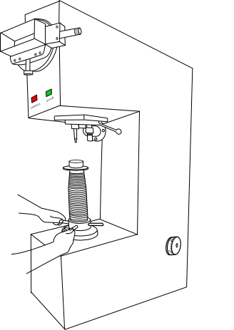

STEP ❸: The load to be applied on a specimen is set by adjusting the knob. (Black triangle inside the knob should be possible to move in same direction to set the load)

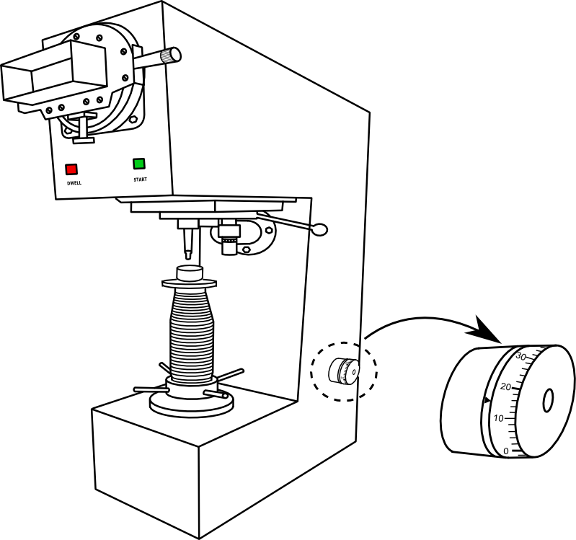

STEP ❹: The time up to which load has to be applied for the specimen is adjusted.

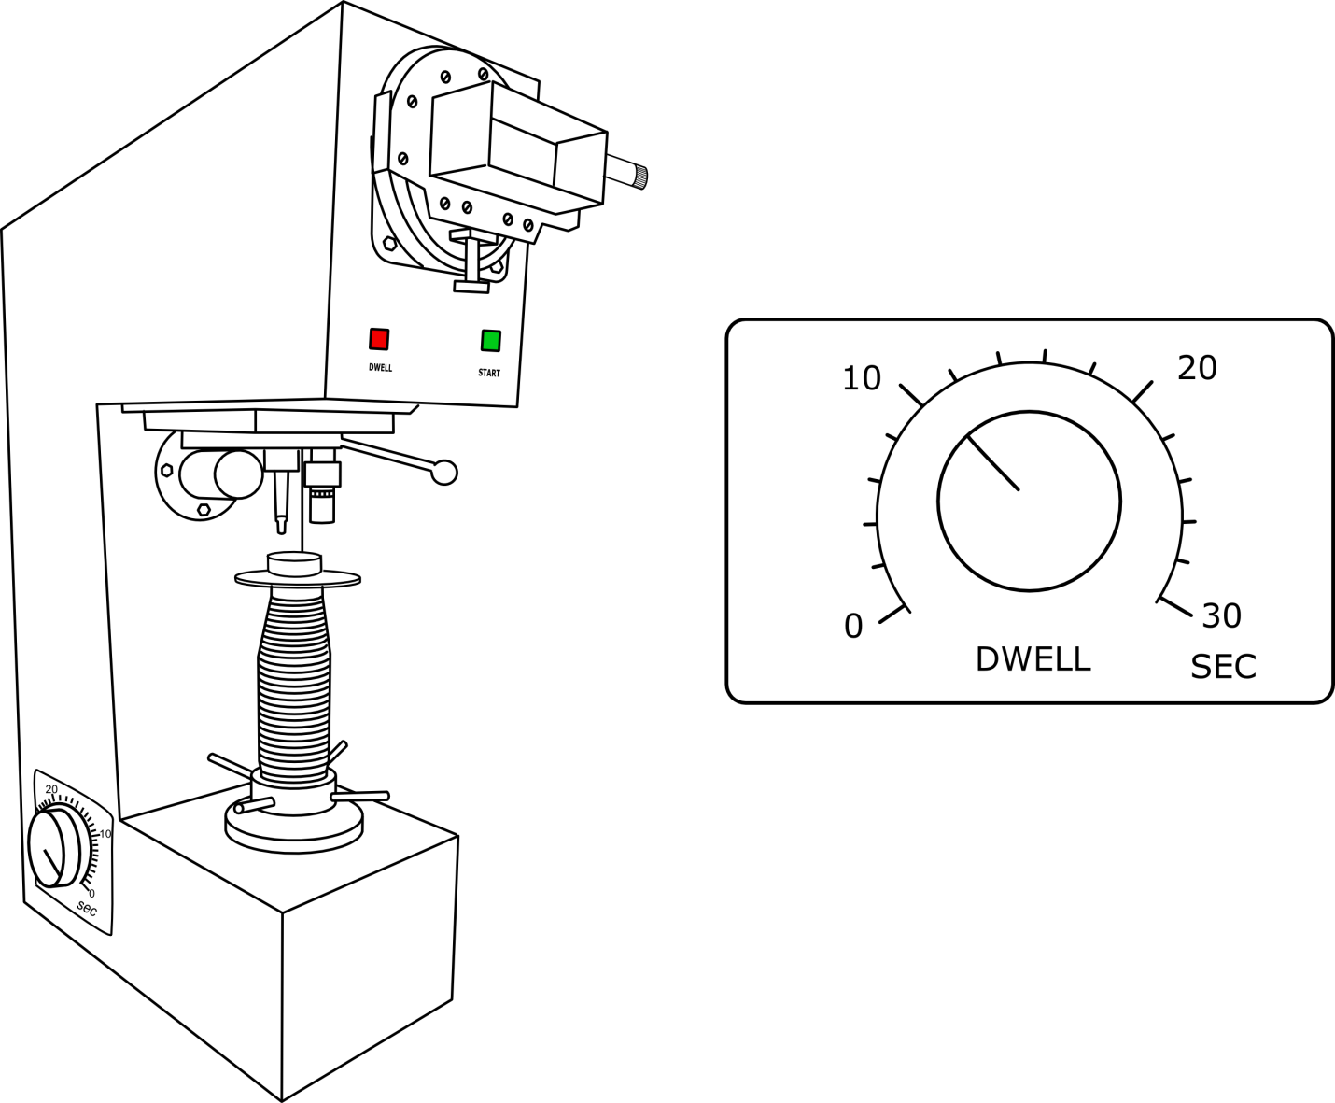

STEP ❺: Apply the selected load by pressing the green button for 2 to 3 seconds until the red light glows.

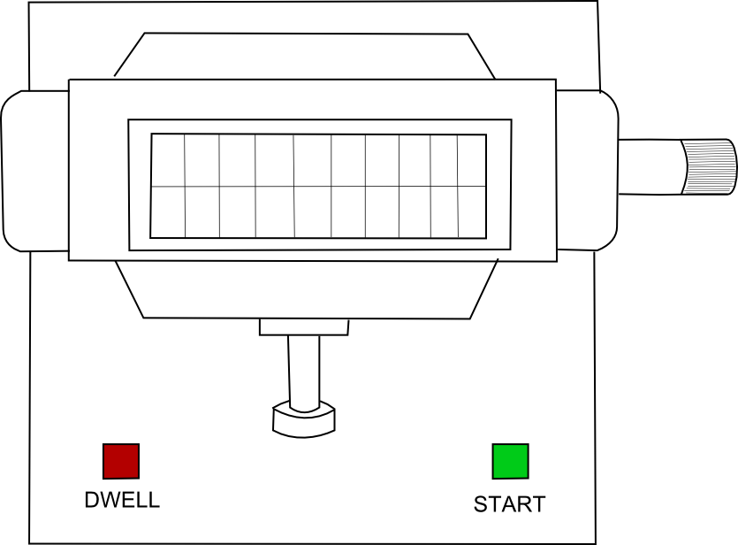

STEP ❻: The image of the impression will now be clearly visible on the screen, measure the diagonal length in X-direction.

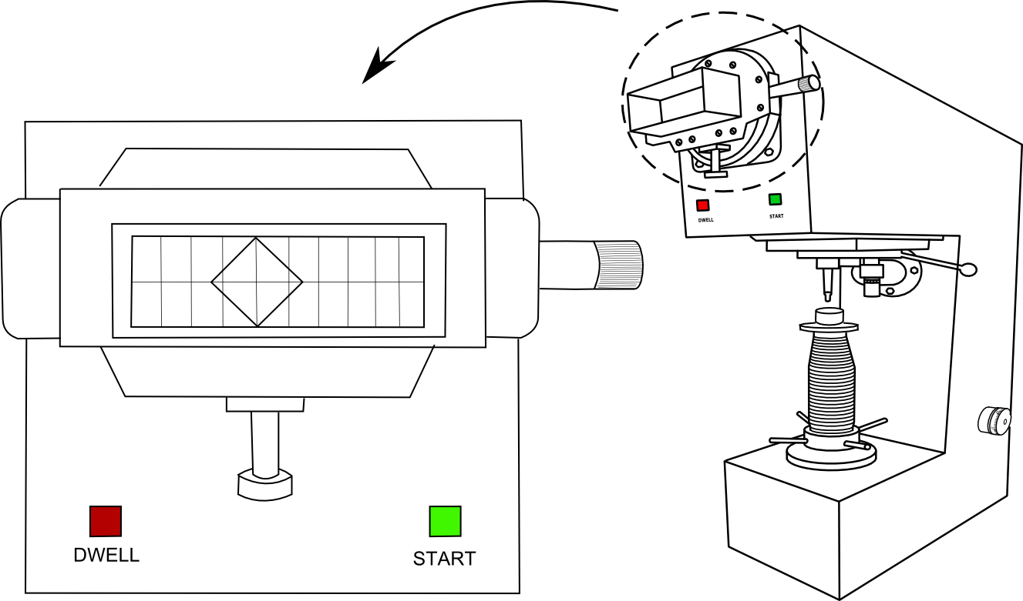

Indentation diagonal length in X-direction=_________

STEP ❼: Measure the diagonal length in Y-direction.

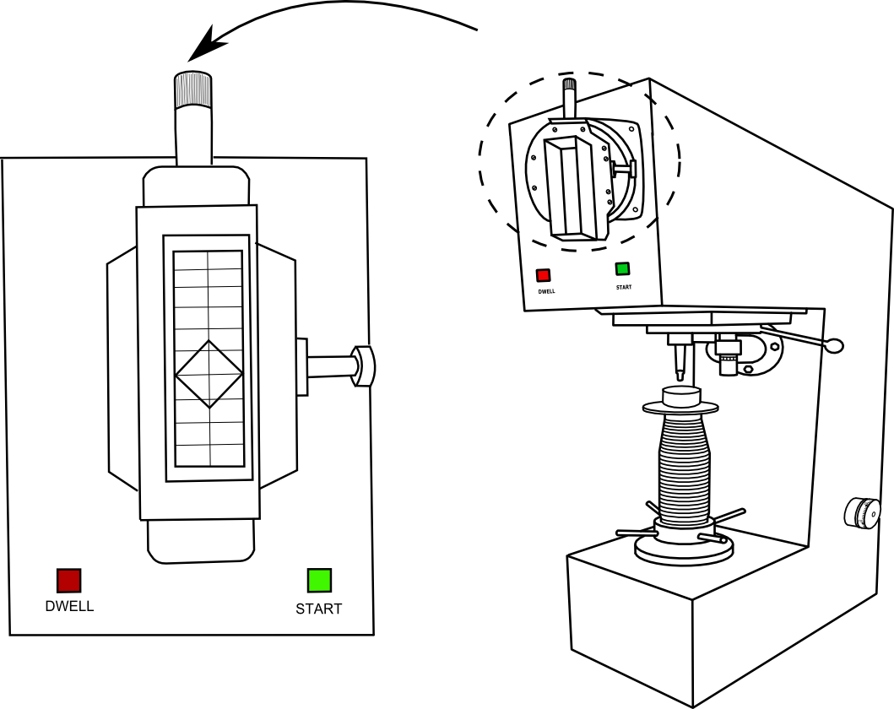

Indentation diagonal length in Y-direction=__________

# STEP ❽:

Calculations:

|  |  |  |  |  |  |  |  |
| --- | --- | --- | --- | --- | --- | --- | --- |
| Sl no | Specimen | Load Applied in kg | Diagonal of indentation in mm | | | Average Diagonal Length d | Vickers Hardness Number hv=0.8191F/d2 |
| d1 | d2 | |
|  |  |  |  | |  |  |  |

Result: The Vickers hardness number of given specimen is________